Hajj Instant Reference
Time of the day
Dates | 8th | 9th | 10th | 11th | 12th | [13th]
Dawn (Subah Sadiq) |  |  |  | Time to stone big Jamaraat ends | Time to stone 3 Jamaraats of 11th ends | Time to stone 3 Jamaraats of 12th ends
Fajr |  | In Mina | In Muzdalifah | In Mina | In Mina | In Mina
After-Sunrise | Proceed to Mina1 | Proceed to Arafah | - Stay in Muzdalifah until sunrise  - Proceed towards the Jamaraat Area
After-Zawaal |  | Stay in Arafah from Zawaal until sunset | Actions of 10th Dhul Hajj  a) Throw 7 pebbles at Jamarah Uqba ONLY (Big Pillar of Shaytaan /Evil – closer to Makkah)  b) Slaughter Animal (Qurbani) 5  c) Shave Head  d) Remove Ahram and wear normal cloth6 | - Proceed to Jamaraat Area  - Throw 7 pebbles each on the 3 Jamaraats in following order  SMALL (pillar closer to Masjid Khaif), MEDIUM, BIG (pillar closer to Makkah) | - Proceed to Jamaraat Area  - Throw 7 pebbles each on the 3 Jamaraats in following order  SMALL (pillar closer to Masjid Khaif), MEDIUM, BIG (pillar closer to Makkah) | - Proceed to Jamaraat Area  - Throw 7 pebbles each on the 3 Jamaraats in following order  SMALL (pillar closer to Masjid Khaif), MEDIUM, BIG (pillar closer to Makkah)
Zohar | In Mina | Pray Zohar & Asr combine with Imaam of Masjid Nimrah in Arafah | In Makkah (or Mina) | In Mina | In Mina | In Mina
Asr | In Mina | DO A LOT OF DUA AND SEEK FORGIVENESS. DO NOT WASTE THIS PRECIOUS TIME IN ARAFAH | In Makkah (or Mina)  e) Perform Tawaf-e-Ifadah (Ziyarah) 7  f) Perform Hajj Saee  Afdhal Time for throwing pebbles on big Jamaraat ends before sunset | Afdhal time for throwing stones on 3 Jamaraat ends before sunset | Leave before sunset if you do not intend to stay in Mina beyond two days | Leave before sunset to Makkah
After Sunset |  | Proceed to Muzdalifah WITHOUT praying Maghrib |  |  |  | Perfrom Tawaf-e-Wida (farewell) before leaving Makkah for your home
Maghrib | In Mina |  | In Mina | In Mina | In Mina
Isha | In Mina | Pray Maghrib & Isha combine in Muzdalifah3 | In Mina | In Mina | In Mina
Sleep/ Wait at night | In Mina | Sleep in Muzdalifah  Collect 7+(7*3*3) = 70 pebbles4. | In Mina8 | In Mina | In Mina
Note:
(a) Wajibaat’s (must-do) of Hajj are printed in bold-italic fonts in table above. A Waajib (must-do) if missed or performed incorrectly can be compensated by giving Dum (sacrificing an animal within the boundaries of Makkah).
(b) Wearing Ahram, Staying in Arafah on 9th Dhul Hajj between Zawaal time and sunset for atleast a moment and Tawaf-e- Ifadah (Ziyarah) are the Faraidh (compulsory acts) of Hajj.
If any of them is missed then the whole Hajj is null and void and has to be redone again in future by the pilgrim.
Ahram (before reaching Meeqat)  - Wear two unstiched cloth  - Pray two rakah salaah  - Leave head uncovered  Ahram for women: Normal clothing covering the whole body but not the face and hands. | Umrah  - Do Tawaaf (seven rounds) of the Kaaba  - Pray two rakah at Maqame(Place of) Ibrahim  - Perform Saee (walk between Safa & Marwa mounts)  - Shave all or trim 1/4th of the hair on the head  Women should trim only finger-tip (about 2cm) length of their hair. | Types of Hajj  - Hajj Tamattu (making Umrah & Hajj in the same journey in the same year)  - Hajj Qiran (making Umrah & Hajj at the same time in the same journey)  - Hajj Ifrad (making only Hajj)
Meeqats  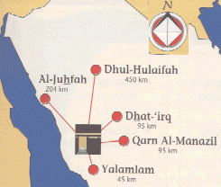  Al-Masjid Al-Haraam  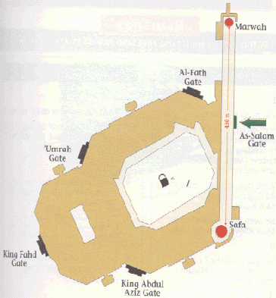 | Tawaaf  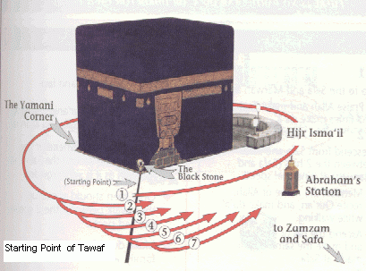  Saee  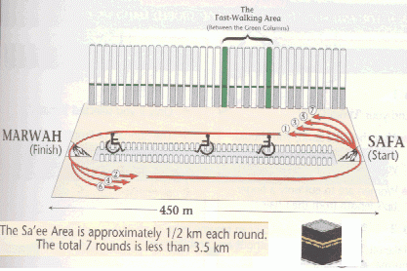 | Distance Between places  Jamaraat Area  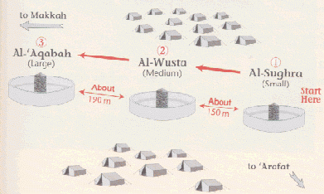  Be careful near Jamaraat. Do not bend
sarguroh@hotmail.com

1 Hajj-Qiran pilgrim (one who wears Ahram, performs Umrah and remains in Ahram till the completion of Hajj) will go straight to Mina. Hajj-Tamattu pilgrim (one who wears Ahram, performs Umrah then removes Ahram to wear again for Hajj) & Hajj-Ifraad pilgrim (one who wears Hajj Ahram and directly proceeds to Mina on 8th) will wear their Ahram now and proceed to Mina.
5 If you are perfoming Hajj Ifraad pilgrim, you do not need to sacrifice animal.
6 Prohibitions of Ahram state are no longer applicable except sexual intercourse, which will be lifted once the pilgrim(Haji) performs Tawaf-e-Ziyarah & Hajj Saee.
7 Time to perform Tawaf-e-Ziyarah & Hajj Saee is applicable until sunset of 12th Dhul Hajj.
3 It is a must to combine the two prayers Maghrib & Isha in Muzdalifah on this night of 10th Dhul Hajj.
4 If you are planning to stay for only two nights (11th & 12th) in Mina then collect only 7+(7*3*2)=49 pebbles. You might want to collect a few extra pebbles to make sure you have enough.
8 It is important to stay for a major part of every night (11th,12th &/or 13th) in Mina. You could be in Makkah for Tawaf-e-Ifadah, so you can pray these salaah there too.

